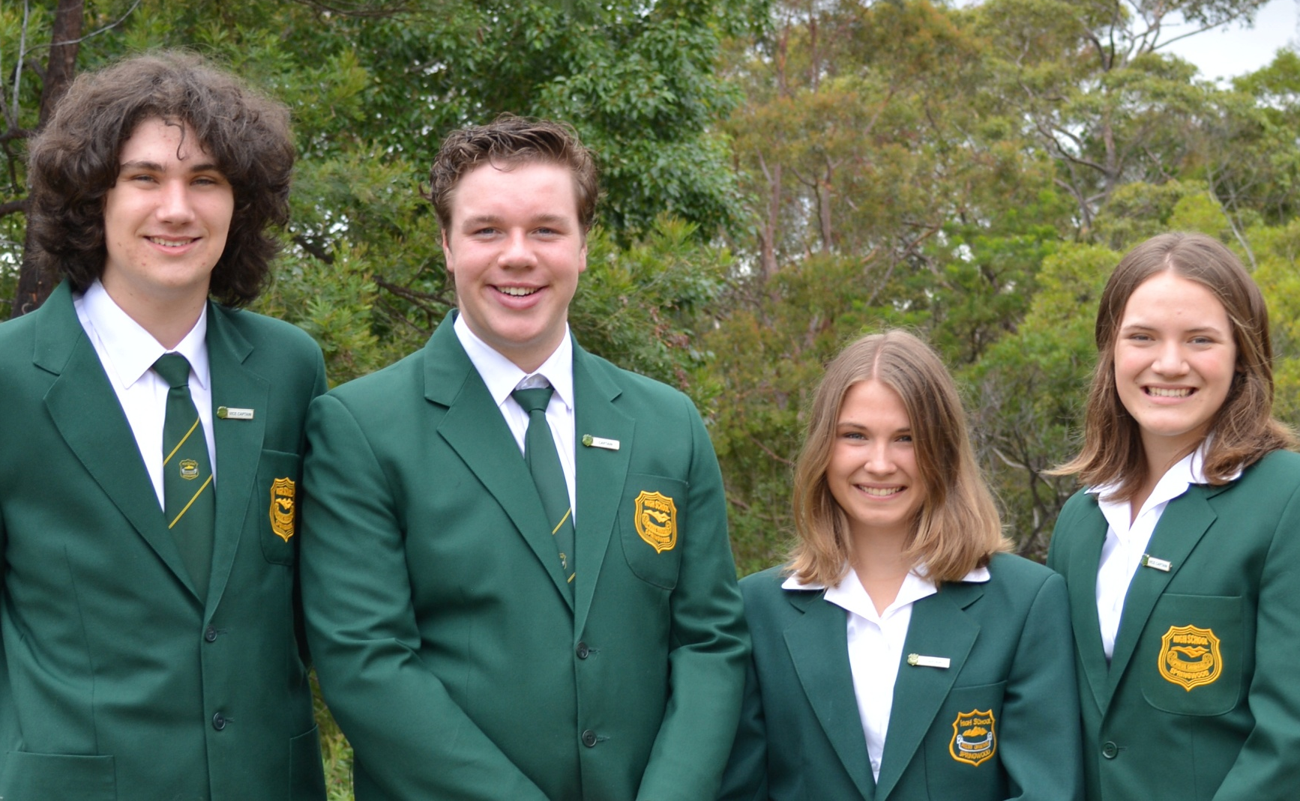
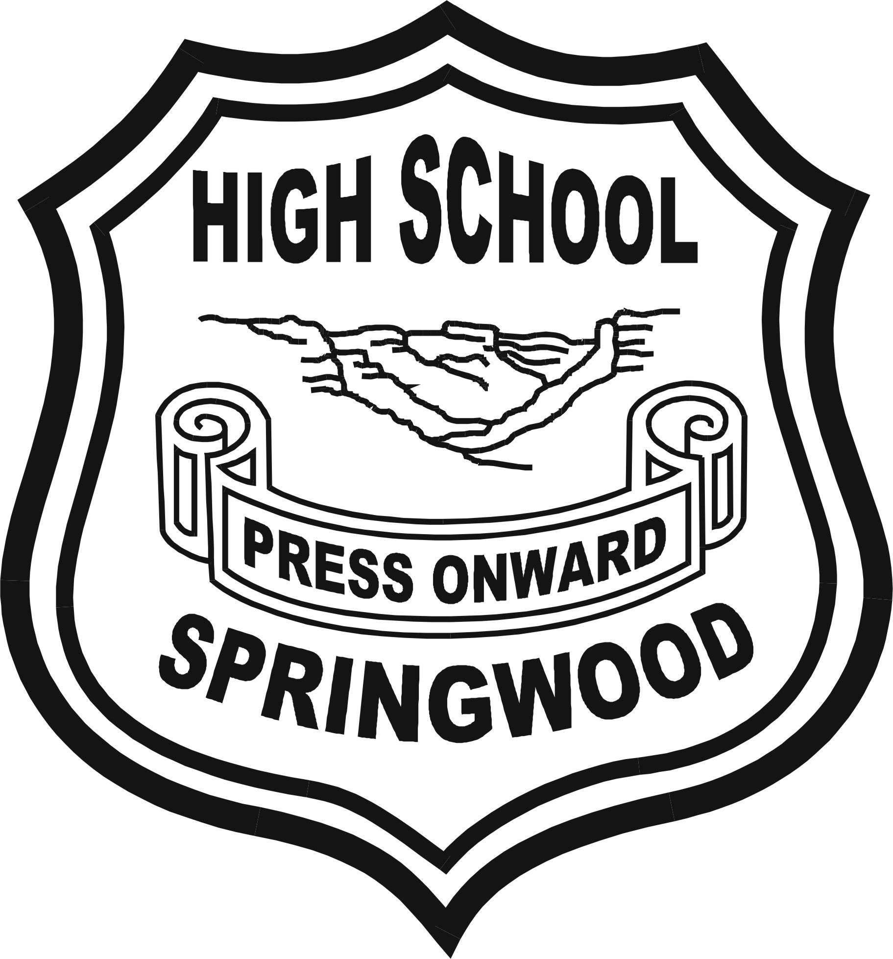
Inspired learning
Excellence, Creativity, Success

Springwood High School is located in the Blue Mountains and has a proud history as a public comprehensive high school serving the mid-mountain’s communities. Our school fosters individual academic success and student achievement in a diverse range of cultural activities including the creative and performing arts and sport.
A place where your child is treated as an individual in a nurturing environment

Springwood High School promotes academic excellence, whilst recognising that differences exist in the abilities and talents of individual students. We seek to personalise learning for our students, catering for individual needs. Our student welfare and learning programs teach students to value and respect the well-being of others within a collective ethos that emphasises learning, safety and respect for all.
The relationships between teachers, students and parents provide the foundation for the happy and welcoming environment that is characteristic of our school. Our attractive and spacious setting provides a friendly environment where students feel safe and secure.

“Springwood High offers students a well-rounded, holistic education. I like the way students are given the opportunity to showcase what they have learnt and the way they are supportive of each other.” Lisa Bleijie, parent 2011.

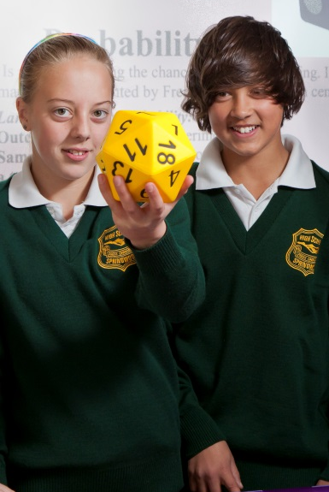

Welcome to Springwood High School
It is a privilege to be the Principal of Springwood High School, a school with a very proud history. We teach and support our students to achieve their best as learners and as people in a safe and respectful environment.
Quality teaching and learning is the cornerstone of all that we do. We offer a broad curriculum, catering for the diversity of our students’ needs, interests and aspirations. Students also have many opportunities for involvement in wider school activities, including student leadership, a wide range of sports and many cultural activities.
The Mid-Mountains Learning Community, which provides supportive links and relationships with our partner primary schools, supports a smooth transition to high school for students.
We believe education is a partnership between school and home, and we value our relationships with parents and carers.
Please feel free to contact the school for more information or an interview.
Dr Mark Howie

Mrs Robyn Asboth, Principal
Our students benefit from:

• Highly qualified, experienced and skilled teachers
• Wide subject choices, including Vocational Education Training in senior years
• A strong tradition of excellent academic performance in the Higher School Certificate
• Innovative technology programs utilising wireless internet access in every classroom
• Modern school facilities such as the Trade Training Centre for hospitality, video conferencing facilities and interactive whiteboards
• A successful sporting program, including a wide range of competitive and recreational sports such as soccer, hockey, basketball, swimming, fitness and archery
• A primary links program providing a smooth transition from primary to high school
• An active and dedicated P&C supporting the school through the annual Art Show and Celebrating Design Artisan Market
• Regular performance opportunities in Drama, Dance and Music

“The thing that I remember most about Springwood High was the fantastic rapport that I developed with my teachers over the years.” Ex-Student

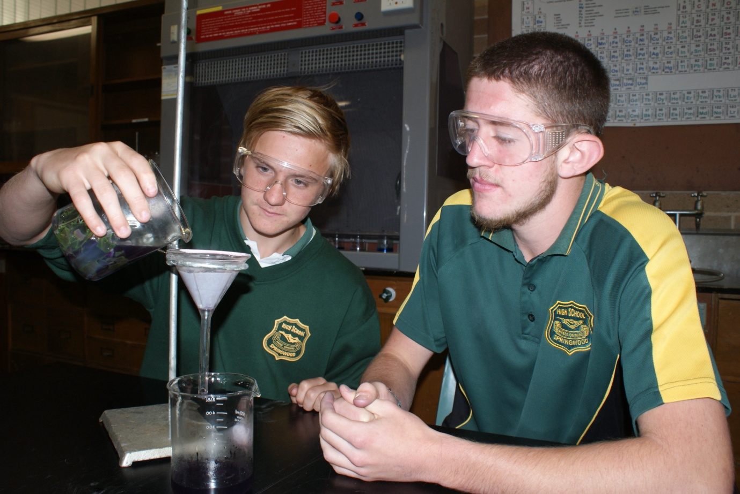
For more information contact:

Dr Mark Howie, Principal
Springwood High School
Grose Road
Faulconbridge NSW 2776

T: (02) 4751 2111
F: (02) 4751 1677
E: springwood-h.school@det.nsw.edu.au
W: springwood-h.schools.det.nsw.edu.au
